**Laboratory -: Package and Inheritance**

# Task-1: Package creation and import

1. Done
2. Done
3. Done
4. Done
5. While I am compiling the File, it shows me some errors on JCreator :
   1. Error: Main method not found in class package1.ClassA, please define the main method as: public static void main(String[] args) or a JavaFX application class must extend javafx.application.Application
   2. I found the ClassA.class file on this path: C:\Users\alami\OneDrive\Documents\package1
6. package package1; is defining the package name of ClassA; means ClassA belongs to package1 and class file will be located inside the declared package name directory.
7. Done
8. Done
9. Done
10. Done
11. Done
12. The errors are:
    1. Error: Could not find or load main class PackageTest
    2. Caused by: java.lang.ClassNotFoundException: PackageTest
13. Added
14. The code compiled and successfully run and print the output “ClassA”. Without the package name, the PackageTest class can’t understand where the ClassA class located. Whenever I place the package name, I mean, import the package name with ClassA, the PackageTest class identify the ClassA and compiled without any error.

# Task-1: Open Sandwich.java program in your editor.

1. Output: 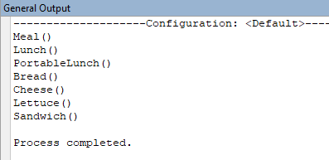
2. If there is inherited constructor, the parent constructor will execute first, then child constructor will execute.
3. In the program, Sandwich class inherit the **PortableLunch** class and PortableLunch class inherit **Lunch** class and Lunch class inherit the **Meal** class. Means, there are total 3 parent class for Sandwich class. As we know, parent class constructor will execute first, therefore, Meal constructor run first, second, Lunch, then PortableLunch constructor executed. As inside the Sandwich Class we instantiated the **Bread, Chesse and Lettuce** class, so they execute one after another before executing the Sandwich constructor. Remember, we have instantiated the Sandwich class inside the main function of program. If we don’t do this, the program output will not show to us.
4. Output: 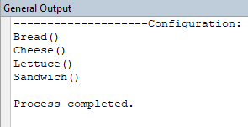
5. I have to remove the inherited class which Sandwich class extends. (e.g **PortableLunch).**